Alex Gillett  
Final Project Proposal

I want to do a crossover/Immaculate Grid style grid but for Pokémon. The concept is you have a 3 x 3 grid and each grid has a category and you have to in 9 guesses get a Pokémon that fits both categories, IE if it was an electric type on the top right and on the top most column it was owned by Ash Ketchum, you would have to guess an electric type Pokémon that was owned by Ash Ketchum (Pikachu). This would cross-reference a Database to see if the criteria were met and give you a correct and insert the image, or take a guess from you and make you guess again

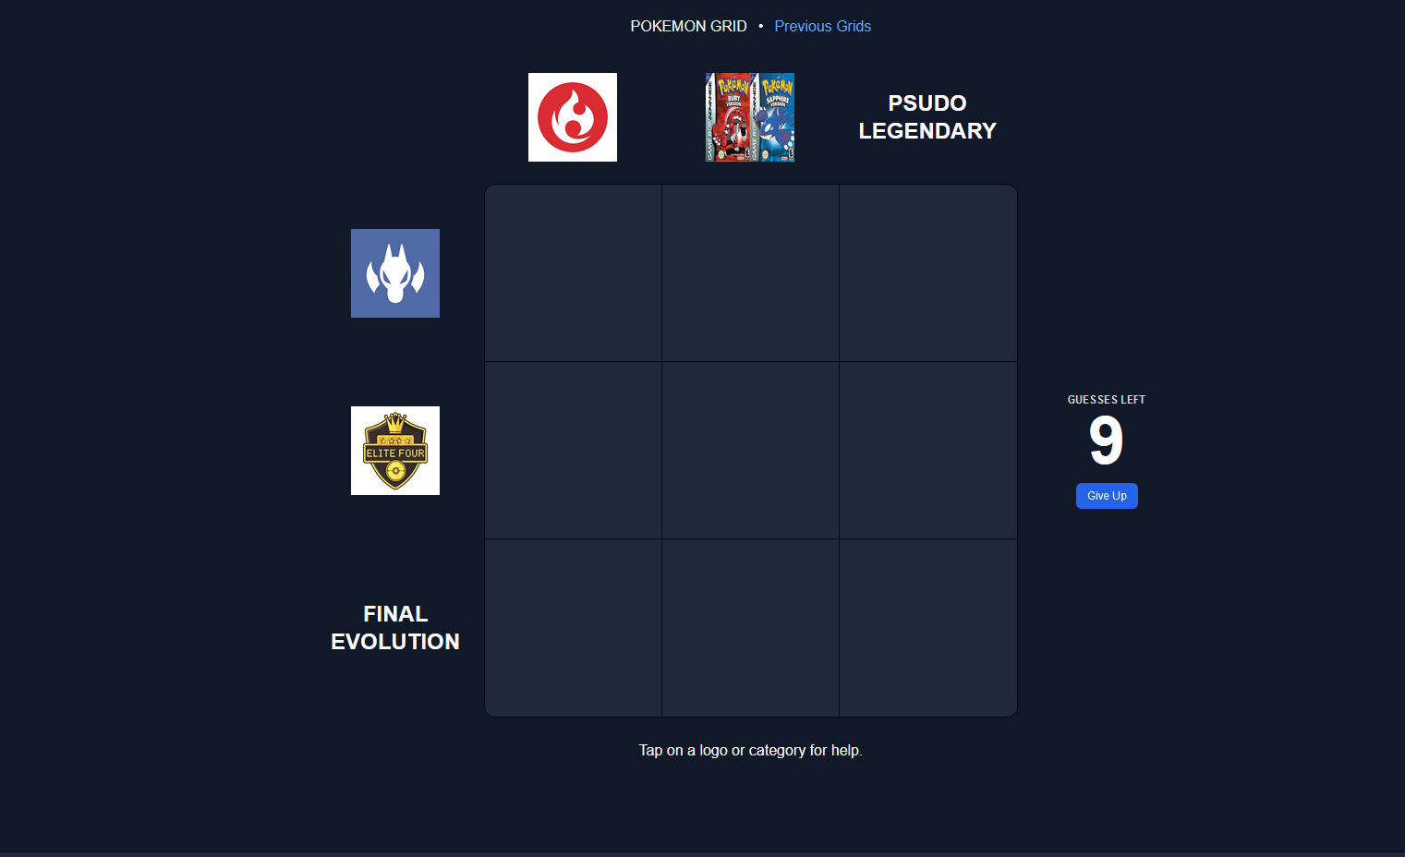

https://github.com/4l3xG/CodingDojoFinalProject